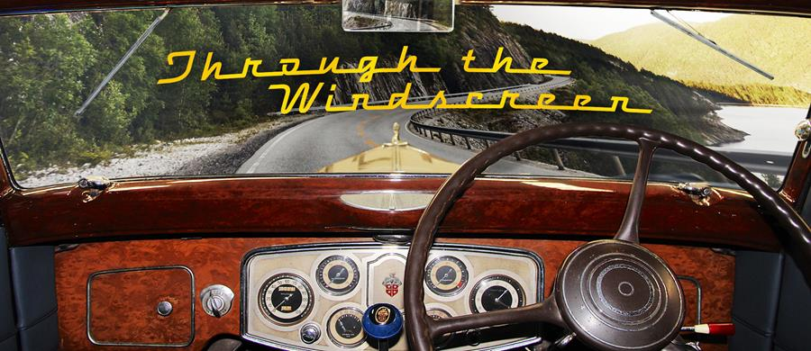

THE LATEST NEWS

Welcome to our April 2023 Newsletter

Our first priority is a huge thank you to the people who donated to our website in the past year. We won't publish your names unless you want us to, but be assured that your appreciation of the effort we've put into building the website has touched us deeply. Thanks again!
It's been a long time since our February-March Newsletter, because we were very busy chasing restoration stories In Tasmania, Victoria and southern NSW. Also, co-founder of the Historic Vehicles website, Jim Gibson, has been crook, but is now on the mend.

What's new on the Historic Vehicles website
When you look at automotive history April is a very interesting month and the stand out isn't that it was the birth month of Walter Chrysler, or the death month of Henry Ford: it was the month back in 1885 when Gottlieb Daimler and Wilhelm Maybach started development of the 'grandfather clock' engine that produced a half-horsepower and propelled the Reitwagen motorcycle.
In News, we wondered why Kenworth didn't make a big fuss in Australia over its 100th anniversary and we were also surprised to learn that Skoda licence-built Hispano Suiza cars in the 1920s. We modified our Hispano Suiza brand story as well.
In Motorcycle Features we covered the evolution of the motorbike, as mentioned above and also the bike content at the National Automotive Museum in Launceston. Another story covers the importance of two BSA Bantams in Tassie's angling history.
In Truck Brands we added Republic and Manchester, and in Working Vehicles we came across Ford Louisvilles still hard at it in Tassie, plus we welcomed our partner website's LandCruiser 75 Series.
One of the Historic Vehicles team, Simon Martin, risked pneumonia getting photos of all the trucks Haulin' the Hume in March and we mourned the loss of one of Australia's pivotal truck engineers, Colin McKenzie.

We've been posting some more of our very high-quality, Historic Vehicles caps to website donors. We're keeping these caps exclusive by giving them only to people who donate A$60 or more to the Historic Vehicles website.
If any of our website visitors know of related businesses that could benefit by advertising their products and services on the Historic Vehicles website, please let them know we're offering 24/7 ads from as little as $550 per annum, including GST - around ten bucks a week.
We'll be busy in the next few weeks checking out a magnificent Cord 810, uploading car pics from our Tassie trip and from the Sapphire Coast Historic Vehicle Club, crawling around a Kenworth 'overnighter ' and visiting a Gardner engine specialist.
All the best for the remainder of autumn, from Jim Gibson, Allan Whiting and the HV Team.

