THE LATEST NEWS

Welcome to our December 2023 - January 2024 Newsletter
As usual, our first priority every month is to thank the appreciative people who have donated to the Historic Vehicles website. HV does have advertising support, headed by Shannons, but we are indebted also to each donor, for helping keep the website content growing every month.
December 2023 marks a 110-year anniversary of the first moving assembly line for car production that went into gear back in 1913, in the Ford Model T plant, in Highland Park, Detroit. Henry Ford borrowed techniques used in breweries and slaughterhouses and combined them with 'still' production lines, to come up with a system that took car production time from around 12 hours to 90 minutes.

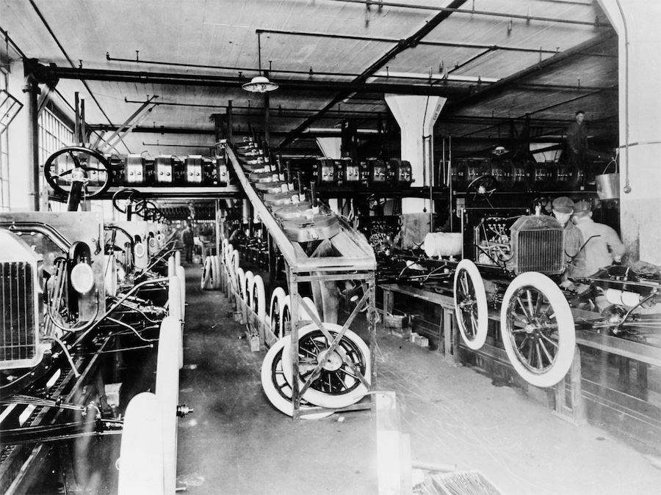

In our News section, we've reported on NTI's charity effort and the record price for a Ferrari GTO.
In Car Features we photographed the highlights at the Cobargo(NSW) Classic Vehicle Rally, the Tipo 184 Alfetta look-alike and a Vegemite centenary model.
In Car Restorations we reported on a classic Pontiac muscle car.
To Motorcycle Brands we've added the Janus retro-bike story.
In Truck Features we reported on a Model T tow-truck's wedding appearance.

We've been posting some more of our very high-quality, Historic Vehicles caps to website donors. We're keeping these caps exclusive by giving them only to people who donate A$60 or more to the Historic Vehicles website.
Related businesses that could benefit by advertising their products and services on the Historic Vehicles website should note that we're offering 24/7 ads from as little as $550 per annum, including GST - only ten bucks a week - for a 160 x 240 pixel sized advert (approximately vertical business card proportions) . And we'll do the artwork for you free of charge. Just reply to this newsletter email for more info.

We wish you safe travelling over the Silly Season - Jim Gibson and Allan Whiting and the HistoricVehicles team.

