ABOUT US
The C.ex Coffs Sports, Touring & Classic Car Club is an Intra Club of the C.ex Coffs club, located in Vernon Street Coffs Harbour.
OBJECTIVES OF OUR CLUB
The objectives of our club are to promote, foster and encourage the understanding, restoration, and use of sports, touring and classic cars for the benefit of our members.
We achieve this by conducting activities such as car runs, display days, workshops, and social functions such as dinners and barbeques.
We also associate with other clubs, bodies and organisations which may assist in the advancement of these objectives.

MEMBERSHIP
We have a strong membership and welcome new members to our club, regardless of the type or age of vehicle they may own.
In fact, you do not have to own a "special interest" vehicle to join and participate.
To become a member and maintain membership of the C.ex Coffs Sports, Touring and Classic Car Club you must be a financial member of the C.ex Coffs.
Car Club membership fees are currently set at $25 and are due on 1st August annually.
New membership subscriptions paid in the months of May, June, and July will carry membership through to 1st August of the following year.
Members are also required to purchase a name badge. Current production cost of a name badges is $15. Partner badges are optional but recommended.

CLUB MEETINGS
The majority of our General Meetings for members and partners are held on the 1st Monday of every month at C.ex Coffs Club Vernon Street Coffs Harbour, commencing at 7.00pm, except for October when we meet on the 1st Tuesday.
However, during the year we try to hold two of these meetings as a day time meeting with a lunch at the C.ex Woolgoolga and C.ex Urunga. Details of these event changes are advised to members through the events calendar in our newsletter.
Our AGM is held in August and members are advised of the date and venue a month before.

EVENTS GUIDELINES
Our Club has a very well organised Events Committee who ensure our events cater for the interests of all members, partners and their families.
All events are published in our monthly club newsletter, Idle Torque.
If you have any questions regarding a particular run, please call the contact person for that event or one of the Events Committee members.

CONDITIONAL REGISTRATION
Historic Vehicle Scheme H Plate
Classic Vehicle Scheme D Plate (Modified)
The objective of the C.ex Coffs Sports Touring & Classic Car Club is to promote and enjoy motoring in our cars. Members who have vehicles more than thirty years old enjoy the privilege of being able to apply for conditional registration. Conditional registration also allows members to use their vehicle for sixty (60) days personal use under the logbook scheme. Once the application for your Conditional Registration has been received, it will be considered by the Management Committee.
In addition to the RMS rules the C.ex Coffs Sports Touring and Classic Car Club imposes the following rules:

New members must attend two (2) club runs or events before H or D plates will be sanctioned for their vehicle.

Members with H or D plates must attend one (1) club run per year (August to July) in their H or D plated vehicle(s) for the club to sanction the renewal of their plates.

Members with multiple H or D plated cars may attend the runs in any of their plated vehicles.

Guidelines on how to obtain H or D plate registration have been prepared and can be obtained from the club President or Secretary. They are also available from the Car Club’s website. www.cexcoffsstccarclub.info

CONTACT US
In Writing
The Secretary
C.ex Coffs Sports, Touring &
Classic Car Club
PO Box 2068
Coffs Harbour 2450
By Phone
Ian Ward (Club President)
02 6656 1029
Tom Craven (Club Secretary)
0432 508 064
By Email
cexcoffsstccarclub@gmail.com
Website
www.cexcoffsstccarclub.info

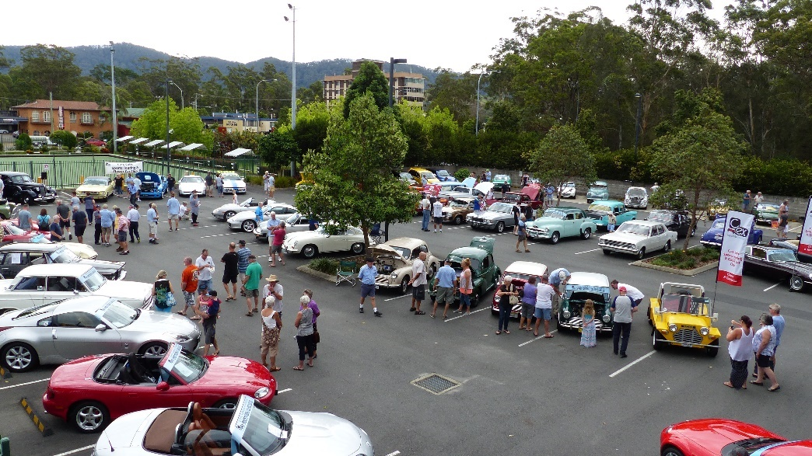

Information contained in this information sheet
is current as at date of publication October 2023

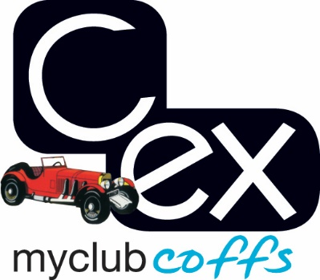

C.ex Coffs

Sports Touring

&

Classic Car Club

NEW MEMBER
INFORMATION

“More than just
a Car Club ”

