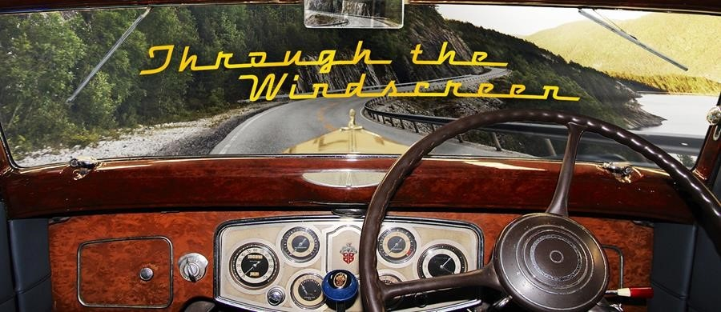

THE LATEST NEWS

Welcome to our June 2023 Newsletter

As usual, our first priority every month is to thank the appreciative people who have donated to the Historic Vehicles website. HV does have advertising support, headed by Shannons, but we are indebted also to each donor, for helping keep the website content growing every month.
The month of June has significance for all us who enjoy turning a key or pressing a button to activate a starter motor. In June, 1911, one Charles Kettering patented his electric starter motor design. Funding for this enterprise came from Henry Leland, founder of Cadillac, whose friend had lost his life, following complications from a broken jaw, caused by a crank handle 'kicking back' at him.
In our News section we've noted: the late, great Tina Turner was a car nut; the Centenary running of the Le Mans 24-hour race; an historic Isle of Man Post Office stamp issue celebrating 100 years of the Manx Grand Prix; farewelled Australian car legend, Bill Buckle; recorded 50 years of UD trucks Down Under; pictured LandRover's limited edition Islay model and added photos of a magnificent wooden model collection in Tasmania.
In Car Restorations we photographed a well preserved and tastefully restored Austin Freeway.
In Car Features we looked at the pros and cons of making replica historic vehicles and attended a blustery National Motoring Heritage Day in Berry NSW.
In Truck Features we noted some of the memorable trucks we came across during our Tassie visit last February and in Motorcycle Brands we added Husqvarna and Magni entries.

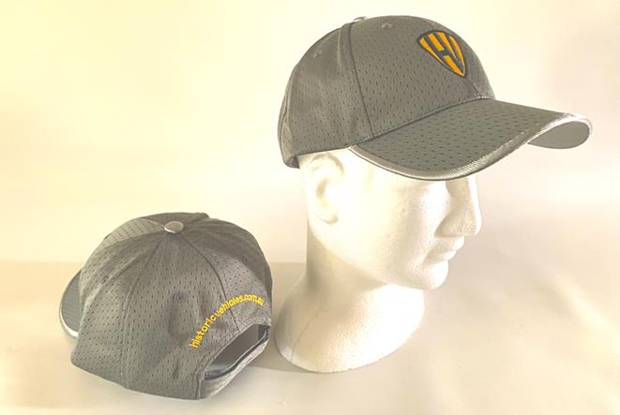

We've been posting some more of our very high-quality, Historic Vehicles caps to website donors. We're keeping these caps exclusive by giving them only to people who donate A$60 or more to the Historic Vehicles website.
If any of our website visitors know of related businesses that could benefit by advertising their products and services on the Historic Vehicles website, please let them know we're offering 24/7 ads from as little as $550 per annum, including GST - around ten bucks a week.
All the best for what is promised to be a warmer than usual winter, from Jim Gibson, Allan Whiting and the HV Team.

