CPR/DEFIBRILLATOR QUARTERLY TRAINING SESSION
PRESENTERS GUIDE

AUTOMATIC EXTERNAL DEFIBRILLATOR (AED)
Display the actual Defibrillator and explain features, operation, maintenance, and accessories.
Check the Readiness Indicator on the AED and quantity of other supplies.

DEFIBRILLATOR CUSTODIAN RESPONSIBILITIES – DEDICATED POSITION
Bring the defibrillator to every club event and advise members in attendance of the device location.
If the custodian cannot attend an event, he/she must appoint a relieving custodian.

DOCTORS ABCD ACTION PLAN
Presenter to explain all steps in the Action Plan.
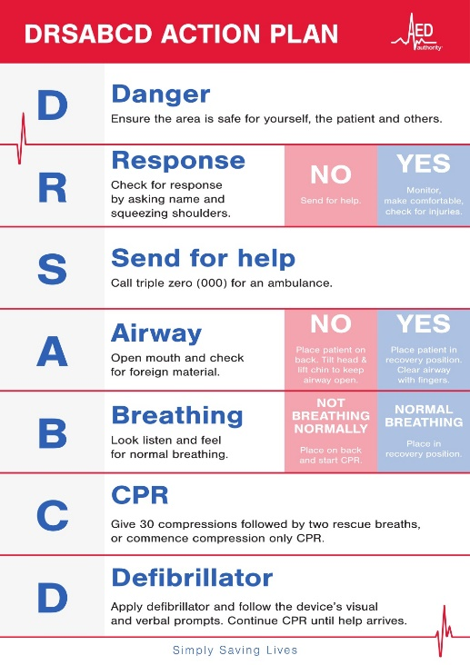
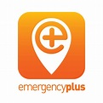

EMERGENCY PLUS APP – All members are encouraged to download this App.
Emergency+ is a national app developed by Australia's emergency services and Government. It contains accurate information and up-to-date technology to identify a caller's location in an emergency. The app also contains numbers for SES and Police Assistance Lines, helping callers access the appropriate phone number for an incident.

EXTERNAL TRAINING
Advise members details of the next six monthly training session at the Sawtell Surf Life Saving Club and check nominations.

TRAINING VIDEOS
Presenter to select and play a video.
AED Authority 4.57
https://www.youtube.com/watch?v=o-uHeD4Icq0
Victor Chan (CPR) 3.51
https://www.youtube.com/watch?v=Plse2FOkV4Q
Victor Chan (Defibrillator) 1.52
https://www.youtube.com/watch?v=2PJR0JyLPZY

