THE LATEST NEWS
Welcome to our September 2023 Newsletter
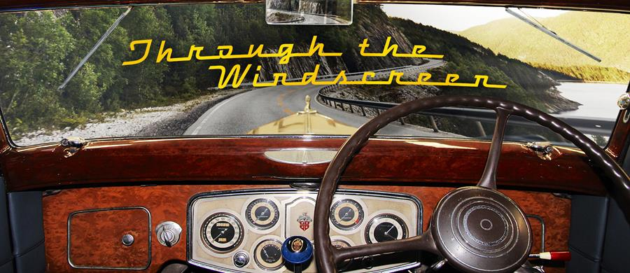
As usual, our first priority every month is to thank the appreciative people who have donated to the Historic Vehicles website. HV does have advertising support, headed by Shannons, but we are indebted also to each donor, for helping keep the website content growing every month.
The month of September, back in 1913, wasn't a good one for Rudolf Diesel, who had boarded the steamer SS Dresden, in Antwerp, bound for London. He never arrived and his body was found floating in the sea, 10 days later.
Theories of murder were fuelled by the fact that Diesel had refused to grant the German armed forces exclusive rights to the use of his engine and that he was discussing its use in UK Royal Navy submarines.
However, he seems to have planned suicide, leaving an unopened bag of cash - US$120,000 in today's dollars - at home with his wife and had drawn a cross in his diary.
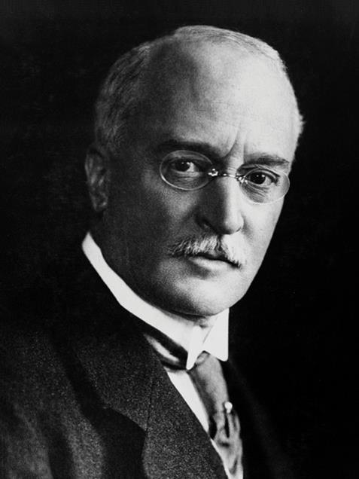
On a much brighter note, in our News section, we've noted that a glorious Mercedes-Benz 540K won this year's Pebble Beach Concours; the last ACCO truck built has been donated to the National Road Transport Museum; USA car fanatics held their annual Cruisin' Rodeo in Italy and we've featured a 100-year-old trouble-shooting guide.
In Car Features we've recorded the rebirth of the Alfa Straddle nameplate; the 70th anniversary of the Jeep Rubicon Trail experience and listed the cars that HV's publishers have owned.
To Car Brands we added listings for Hupmobile and the very rare UK Piper; added some little-known background to the Holden development story and put Pikes Peak footage into the Peugeot entry.
To Motorcycle Brands we've added the Aussie Waratah.
We've added additional engine rebuild information to the Federal resto story in Truck Restorations and in Truck Brands we've added the almost unknown Sentinel models.
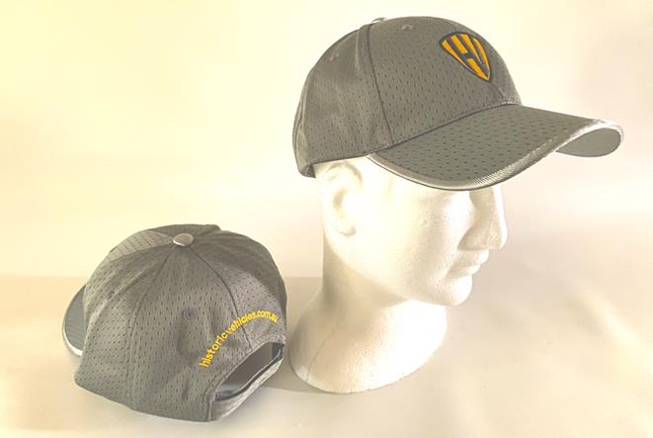

We've been posting some more of our very high-quality, Historic Vehicles caps to website donors. We're keeping these caps exclusive by giving them only to people who donate A$60 or more to the Historic Vehicles website.
Related businesses that could benefit by advertising their products and services on the Historic Vehicles website should note that we're offering 24/7 ads from as little as $550 per annum, including GST - only ten bucks a week - for a 160 x 240 pixel sized advert (approximately vertical business card proportions) . And we'll do the artwork for you free of charge. Just reply to this newsletter email for more info.
We wish you safe travelling now that the warmer weather is with us. Keep the shiny side up - Jim Gibson and Allan Whiting and the HistoricVehicles team.

