**ABOUT US**

The C.ex Coffs Sports, Touring & Classic Car Club is an Intra Club of the C.ex Coffs Club, located in Vernon Street Coffs Harbour.

**OBJECTIVES OF OUR CLUB**

The objectives of our club are to promote, foster, and encourage the understanding, restoration, and use of sports touring and classic cars for the benefit of our members.

We achieve this by conducting activities such as car runs, display days, workshops, and social functions such as dinners and barbeques.

We also associate with other clubs, bodies and organisations which may assist in the advancement of these objectives.

**MEMBERSHIP**

We have a strong membership and welcome new members to our club, regardless of the type or age of vehicle they may own.

Applications for membership must be submitted using the car club’s standard ***Application for Membership* *Form*** available from the car club website, and the applicant must attend a car club General Meeting for introduction before their application can be processed.

To become a member and maintain membership of the C.ex Coffs Sports, Touring and Classic Car Club you must be a financial member of the C.ex Coffs.

Car Club membership fees are currently set at $35 and are due on 1st August annually.

New membership subscriptions paid in the months of May, June, and July will carry membership through to 1st August of the following year.

Members are also required to purchase a name badge. Current production cost of a name badges is $15. Partner badges are optional but recommended.

**CLUB MEETINGS**

Most of our monthly General Meetings for members and partners are held on the 1st Monday of every month at C.ex Coffs Club Vernon Street Coffs Harbour, commencing at 7.00pm, except for October when we meet on the 1st Tuesday.

There is usually no meeting in January, and we try to hold a few meetings as day-time meetings at different venues and include a lunch.

Our AGM is usually held in August.

Please ensure you refer to the Events Calendar in the car club newsletter *“Idle Torque”* to check venues and dates for all meetings.

**EVENT GUIDELINES**

Our car club has a very well organised Events Committee who ensure our events cater for the interests of all members, partners and their families.

All events are published in our monthly club newsletter *“Idle Torque”*.

If you have any questions regarding a particular event, please call the contact person for that event or one of the Events Committee members.

**CONDITIONAL REGISTRATION**

Vehicles submitted must be considered appropriate for our club. Large commercial vehicles, motor homes and vehicles used for work purposes, will not qualify.

Any applications for Conditional Registration (HVS or CVS) must be made in accordance with the guidelines and instructions set down by the NSW Historic Motoring Association and approvals will be subject to the Transport for NSW rules and regulations.

Conditional Registration is considered a privilege and is granted on the basis that those members will actively participate in car club events on a regular basis. New members must attend at least two (2)

club events before applying for either HVS or CVS Conditional Registration. Car club monthly meetings do count as an event for this purpose.

Annual renewal of Conditional Registration is at the discretion of the car club Committee and will be considered based on the members involvement with the car club over the past year, and their individual circumstances.

Members must provide copies of their Conditional Registration papers for vehicles registered under the Historic Vehicle Scheme and the Classic Vehicle Scheme to the club Registration Administrator on initial registration and on renewal within seven (7) days of the registration date.

Registration Administrators and Registration Inspectors are not authorised to complete, sign off on, or process, any documentation in relation to Conditional Registration for vehicles where they are the registered owner.

Anymodifications and other alterations made to the vehicle after inspections for HVS and CVS registration must be immediately notified to the Registration Administrator.

Referral Websites

**C.ex Coffs S,T & C Car Club**

***[www.cexcoffstccarclub.info](http://www.cexcoffstccarclub.info)***

**NSW Historic Motoring Association**

***https://www.nswhma.org.au***

**Transport for NSW**

***https://www.transport.nsw.gov.au***

**CONTACT US**

**In Writing**

The Secretary

C.ex Coffs Sports, Touring &

Classic Car Club

PO Box 2068

Coffs Harbour 2450

**By Phone**

Pat O’Carroll (Club President)

0448 017 048

David Kennedy (Club Secretary)

0455 824 031

**By Email**

[cexcoffsstccarclub@gmail.com](mailto:cexcoffsstccarclub@gmail.com)

**Website**

[*www.cexcoffstccarclub.info*](http://www.cexcoffstccarclub.info)

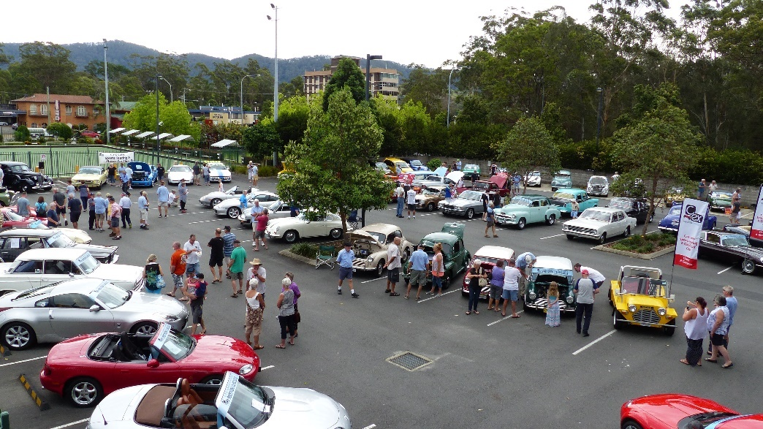

***Information contained in this information sheet***

***is current as at date of publication 3rd August 2025***

C.EX COFFS SPORTS TOURING

&

CLASSIC CAR CLUB

INFORMATION BROCHURE

